## **Project “RPG” 1-Page GDD**

*Diablo styled game*

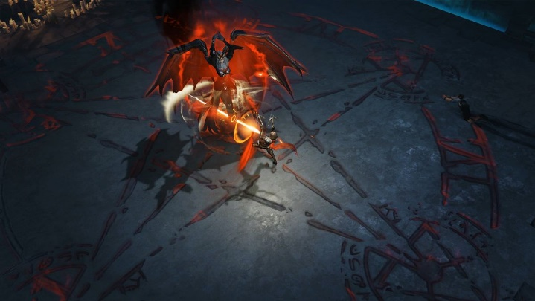

**Genre:** RPG, 3rd person fixed camera RPG.  
**Target Audience:** T for Teen.

**Controls:** Mouse & keyboard, controller.

**Thematic Setting:** Medieval fantasy – swords, knights dragons.

**Tech Stack:** Unity 2018, Blender, Gimp/Photoshop, Audacity.

**Platform(s):** Steam.

**Game Moment:** 2 minutes of simple flow, basic combat (hitting and taking damage) with multiple enemy types.

**Game Summary:**

**Core Player Experience:** Fast fun combat, sense of progression.

**Central Theme:** Fast fun combat.

**Design Pillar:**

**Anticipated Remarkability:**

**Anticipated Steam Early Access Launch date:**

**Feature Development Priorities:**

**Comparative Products:** Diablo, Dungeon Siege

Health and Damage Philosiphies ( 1 – 10)

|  |  |  |  |
| --- | --- | --- | --- |
| Left Most Extreme | Right Most Extreme | Value for our Game | Notes |
| No cost save points | Rogue-like / Permadeath | 6 | Player will respawn at the beginning of the level. Enemies may have respawned by that time |
| Tons of healing | No healing | 7 | The player will not HoT. Player can use healing abilities/potions |
| Unkillable | 1-hit health | 6 | The player will out power the majority of enemies, especially on 1-on-1 combat |
| Easy combat skill | Hard combat skill | 5 | Click to fight, will have abilities to use from a hotbar. |
| Relaxing combat | Stressful combat | 4 | Do not want a stressful combat/dark atmosphere. |
| No player upgrades | Everything is upgradeable | 6 | RPG, so can raise str, dex int etc. Get better weapons and armour. |
| All story | All combat | 5 | RPG, both story and combat are important. |